

Science of the Total Environment 1004 (2025) 180720
Contents lists available at ScienceDirect

Science of the Total Environment

journal homepage: www.elsevier.com/locate/scitotenv

Net zero and net negative emissions in brazilian biomes by no-till system 
Joa˜o Carlos de Moraes Sa´ ^{a,b,*}, Rattan Lal ª, Klaus Lorenz ª, Yadunath Bajgai ª, Carla Gavilan ^{c}, Ademir De Oliveira Ferreira ^{d}, Clever Briedis ^{e}, Thiago Massao Inagaki ^{f},
Daniel Ruiz Potma Gonçalves ^{g}, JeanKleber Bortoluzzi ^{b}
ª CFAES Rattan Lal Center for Carbon Management and Sequestration, School of Environment and Natural Resources, The Ohio State University, 2021 Coffey Road,
Columbus, OH 43210, USA
^{b} Brazilian No-till Systems Federation, Av. Presidente Tancredo Neves; N◦ 6731, CEP: 85867-900, Foz do Iguaçu, Parana´, Brazil
^{c} Department of Environmental Sciences, Rutgers, The State University of New Jersey, New Brunswick, NJ 08901, USA
^{d} Department of Agronomy, Federal Rural University of Pernambuco; Av. Dom Manuel Medeiros, Zip Code 52171900, Recife, PE, Brazil
^{e} Department of Agronomy, Federal University of Viçosa, Av. Peter Henry Rolfs s/n, 36570 900, Viçosa, MG, Brazil
^{f} Department of Biogeochemistry and Soil Quality, Norwegian Institute of Bioeconomy Research (NIBIO), Høgskoleveien 7, 1430, Ås, Norway
^{g} Department of Soil Science and Agriculture Engineering, State University of Ponta Grossa (UEPG), Carlos Cavalcanti Av. 4748, 84030-900, Ponta Grossa, PR, Brazil

H I G H L I G H T S G R A P H I C A L A B S T R A C T

- No-till systems lead to Net zero and Net negative emissions irrespective the climate zone.
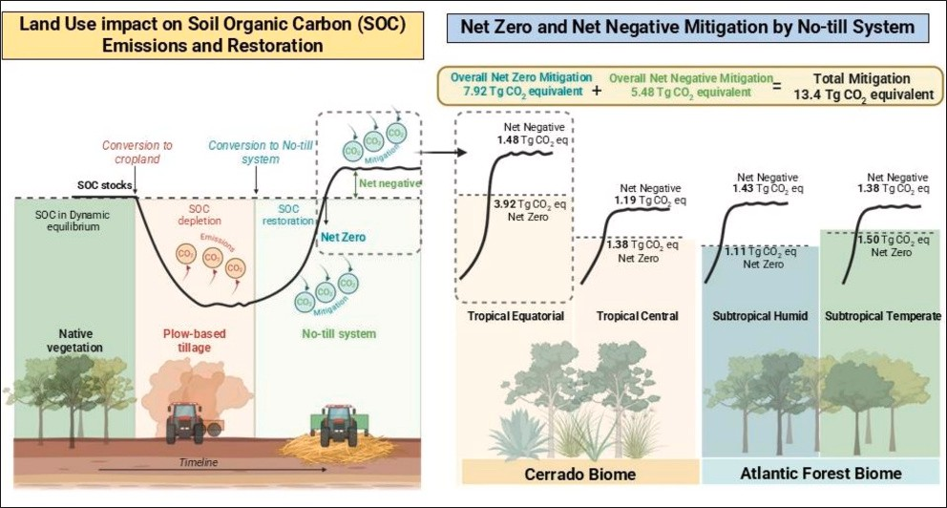
- In average, 73.63 % and 26.37 % of the CO₂ mitigation by no-till systems was Net zero and net negative emissions respectively.
- The lowest CO2e emission was in the equatorial tropical climate zone and the highest in the subtropical humid.
- The intensification of biomass-C via production systems improve net nega- tive emissions.

A R T I C L E I N F O

Keywords:
CO2e Emissions CO2e Mitigation Climatic zones Clusters
Conservation agriculture
A B S T R A C T

No-till systems (NTS) predicated on the tenets of conservation agriculture principles are a viable agricultural paradigm to achieve net zero or net negative emissions. We assessed the carbon dioxide equivalent (CO₂e) emissions based on soil organic carbon (SOC) stock changes in 1-m depth by plow-based tillage (PBT) and the
mitigation potential through a no-till system (NTS) across 26 sites in the Cerrado biome and 37 sites in the Atlantic Forest biome. These sites comprise 86,411 ha (ha), encompassing four climate zones in Brazil. The investigation revealed a range of CO e emissions, with the lowest recorded value of 74.2 Mg CO e ha^{—1} observed

2 2
in the tropical equatorial climate zone and the highest recorded value of 470.1 Mg CO₂e ha^{—1} detected in the subtropical humid climate zone. The total CO₂e emissions in the tropical equatorial, tropical central, subtropical humid and subtropical temperate climate zones were calculated to be 5.51, 3.88, 3.21, and 4.20 Tg CO₂e, respectively, with a cumulative value of 16.80 Tg CO₂e with 6.7 % of uncertainty (i.e., 1.12 Tg CO₂e). Adoption

* Corresponding author at: CFAES Rattan Lal Center for Carbon Management and Sequestration, School of Environment and Natural Resources, The Ohio State University, 2021 Coffey Road, Columbus, OH 43210, USA.
E-mail address: jcmoraessa@yahoo.com.br (J.C. de Moraes Sa´).

https://doi.org/10.1016/j.scitotenv.2025.180720
Received 8 July 2025; Received in revised form 10 October 2025; Accepted 10 October 2025
0048-9697/Published by Elsevier B.V.

of NTS demonstrated a high capacity for offsetting CO₂ emissions, achieving 5.40 Tg CO₂e in the tropical equatorial zone (recovering 98 % of the total emissions), 2.57 Tg CO₂e in the tropical central zone (68.7 %), 2.67 Tg CO₂e in the subtropical humid zone (83.2 %), and 2.88 Tg CO₂e in the subtropical temperate zone (68.6 %). The percentage of net zero and net negative emissions contributed by the SOC stock for 1-m depth was 73.63 % and 26.37 %, respectively, and it played a pivotal role in integrating agriculture as a part of the climate solution.

Introduction

Achieving global climate goals requires a reduction in net green- house gas (GHG) emissions including those from the agrifood system (Anderson et al., 2020). Food production is responsible for approxi- mately 25 % of global greenhouse gas (GHG) emissions (Crippa et al., 2021), and this figure is estimated to rise to around 33 % when taking all agricultural products into consideration (Poore and Nemecek, 2018).
A critical issue for the international scientific community pertains to the assessment of the agricultural sector’s role in attaining net zero and net negative emissions by soil management (Brander et al., 2021). Net zero emissions imply that all carbon emissions from soil are counter- balanced by a comparable removal of carbon dioxide (CO₂) from the atmosphere (Brander et al., 2021; Griscom et al., 2017). Conversely, net negative emissions refer to a scenario in which the removal of CO₂ ex- ceeds the net zero level by land-use and management (Fankhauser et al., 2022) relative to the baseline under native vegetation (NV) character- izing the dynamic equilibrium of the soil organic carbon (SOC) stock. In this context, the term “soil carbon (C) dynamic equilibrium” is employed to denote the balance between carbon inputs and outputs in soil eco- systems (Ramesh et al., 2019). This equilibrium is considered as stable and context-specific, shaped by local factors such as soil type, climate, and management practices.
The discourse surrounding agriculture as a climate solution entails a considerable degree of uncertainty with respect to the issue of C sequestration (Hasegawa et al., 2021). First, climate fluctuations pri- marily affect the amount and distribution of annual precipitation and the mean annual temperature that exerts a direct impact on crop growth and the return of crop-C to the soil (Abbass et al., 2022). Secondly, the total land area of the Earth, excluding Antarctica and inland waters, is estimated to be approximately 13 billion hectares. In 2021, the total area of agricultural land was 4.8 billion hectares, while forest land and other land areas were 4.1 billion hectares each. Within agricultural land, cropland occupied 1.6 to 1.9 billion hectares in 2021, while the area of permanent meadows and pastures was 3.2 billion hectares (FAO, 2021). However, only 0.205 Bha adopts conservation agriculture for soil erosion control and the enhancement of crop’s performance and envi- ronment preservation (Kassam et al., 2022). The extensive employment of plow-based tillage in over 80 % of cropland is a primary factor contributing to the agricultural sector’s failure to make a contribution to
climate change mitigation (Kassam et al., 2022).
Nevertheless, a substantial body of research has identified a range of agricultural strategies with the potential to mitigate GHG emissions (Jeswani et al., 2022). These strategies encompass several approaches including the refinement of nitrogen (N) fertilizer production to curtail nitrous oxide (N₂O) emissions (Nyvold and Do¨rsch, 2025; Wang et al., 2021; Yang et al., 2024), the enhancement of biological N fixation across diverse species to reduce the need for N addition (Hungria and Nogueira, 2023; Jensen and Hauggaard-Nielsen, 2003; Minamisawa, 2022), the augmentation of agricultural machinery efficiency towards the reduc- tion of fossil fuel consumption (Hungria and Nogueira, 2023), the viability of the farm operation to minimize the use of external inputs (Jensen et al., 2025), the adoption of best management practices (BMPs) to avert soil erosion and nutrient leaching and increase crop produc- tivity (Lal and Moldenhauer, 1987), the employment of bio-stimulants, bio-fertilizers, bio-controllers and microorganisms to enhance crop performance (Goulding et al., 2007; Rouphael and Colla, 2020; Zulfiqar et al., 2024), and the implementation of no-till systems (NTS) based on
biomass-C input. No-till (NT) is a management system designed to reduce soil erosion and risks of land degradation (Lal et al., 2007) that has the potential to increase cropland SOC stocks. Brazil has 36.8 Mha of land dedicated to annual crops under NTS (Kassam et al., 2022), which corresponds to approximately 55.8 % of the total area allocated to grain production.
The minimum amount of crop residue needed to maintain a C dy- namic equilibrium under NTS was investigated in tropical and sub- tropical regions in Brazil, with a focus on the soil type and texture, their critical thresholds, and their relationship with the duration of NTS. In a subtropical humid region under NTS, an annual input of 4.2 Mg C ha^{—1} was estimated to be required to maintain the C stocks of an Ultisol at a stable level (Lovato et al., 2004). Conversely, under conventional tillage, the required input would be more than double that under NTS, at 8.9 Mg C ha^{—1} year^{—1}.
Moreover, a study conducted in an Oxisol within a subtropical humid climate reported that the minimum biomass-C input required to main- tain a C dynamic equilibrium in that region was 3.2 Mg C ha^{—1} yr^{—1} (equivalent to 7.3 Mg ha^{—1} yr^{—1} of plant biomass) (de Oliveira Ferreira et al., 2012). Furthermore, Sa´ et al. (2015) estimated the minimum amount of biomass C-input required to maintain the dynamic equilib- rium at 5.1 to 5.85 Mg C ha^{—1} yr^{—1} (11.6 to 13.3 Mg ha^{—1} yr^{—1} of plant biomass).
A recent study demonstrated that the adopting NTS considerably enhances agriculture’s climate mitigation potential and improves envi- ronmental quality (Sa´ et al., 2025). The findings for biomes in Brazil indicate that the long-term NTS, predicated on the tenets of conservation agriculture (CA) principles (i.e., absence of soil disturbance, constrained to the sowing line, ensuring permanent soil cover, and diversified crop rotation), has a potential to restore SOC. This paradigm is poised to play a crucial role in addressing the pressing environmental challenges posed by the climate crisis, particularly the reduction of the agricultural sec- tor’s carbon footprint. Findings by Sa´ et al. (2025) have emphasized that, irrespective of climate zone, 16 out of 63 NTS sites had SOC stocks (0–100 cm soil depth) exceeding those under native vegetation, achieving net negative emissions; while 27 sites had recovered 80 to 100 % of the SOC stocks found under native vegetation. The challenge is to manage the amount of biomass-C necessary to attain the dynamic equilibrium (amount equivalent to net zero emissions) while concur- rently surpassing this threshold to achieve net negative emissions. In this study, a protocol was proposed to achieve net zero and net negative emissions in agricultural production systems under NTS. This protocol draws upon the scientific findings regarding the loss of SOC stock in the 0–100 cm layer resulting from the continuous use of plow-based tillage (PBT) and the subsequent SOC gain through the implementation of long- term NTS within the Cerrado and Atlantic Forest biomes in Brazil. Furthermore, the specific research questions guiding this study were as follows: 1) What is the size of the SOC of CO₂e mitigated by NTS in subtropical and tropical agroecosystems in Brazil? 2) What is the amount of crop residue (above and belowground) that corresponds to the C sequestration rate in each climate zone? 3) How can the amount of biomass-C required to reach net zero and net negative emissions be calculated?
The specific objective of the present study was to assess the potential of NTS to promote net zero and net negative emissions in subtropical and tropical agroecosystems in Brazil. To this end, the study examined 26 sites in the Cerrado and 37 sites in the Atlantic Forest biome, comparing SOC stock (1-m depth) under native vegetation (NV), PBT and NTS

which encompass four climate zones (tropical equatorial, tropical cen- tral, subtropical humid and subtropical temperate). The hypothesis was formulated that net zero and net negative emissions are directly asso- ciated with the amount of biomass-C input to reach the concept of SOC dynamic equilibrium.

Material and methods

  - Study sites and biomes

The present study included 63 sites, which were distributed among two Brazilian biomes (Fig. 1 and Table 1). A total of 26 sites were located in the Cerrado and 37 in the Atlantic Forest biomes. These sites were distributed across four distinct climate zones: tropical equatorial,
tropical central, subtropical humid, and subtropical temperate. These sites were specifically selected to represent a range of latitudes within Brazil, extending from —7◦ South to —28◦ South. Each site encompassed three land use types (LUT), represented by native vegetation (NV), plow- based tillage (PBT) and no-till systems soil which were then compared to assess the losses, gains, and restoration of soil organic carbon (SOC) stocks (details in S´a et al. (2025)).
Briefly, the Cerrado biome (Fig. 1 and Table 1) is a tropical savanna biome with annual rainfall ranging between 600 and 2000 mm, increasing from east to west, and total annual amount of 1430 mm (Alvares et al., 2013). Approximately 50 % of the biome receives annual
rainfall of 1400 to 1600 mm. The MAT is >26 ◦C in the northern region of Mato Grosso state and < 18 ◦C in the southernmost region. The biome
is characterized by a vast and diverse array of vegetative cover, land use,

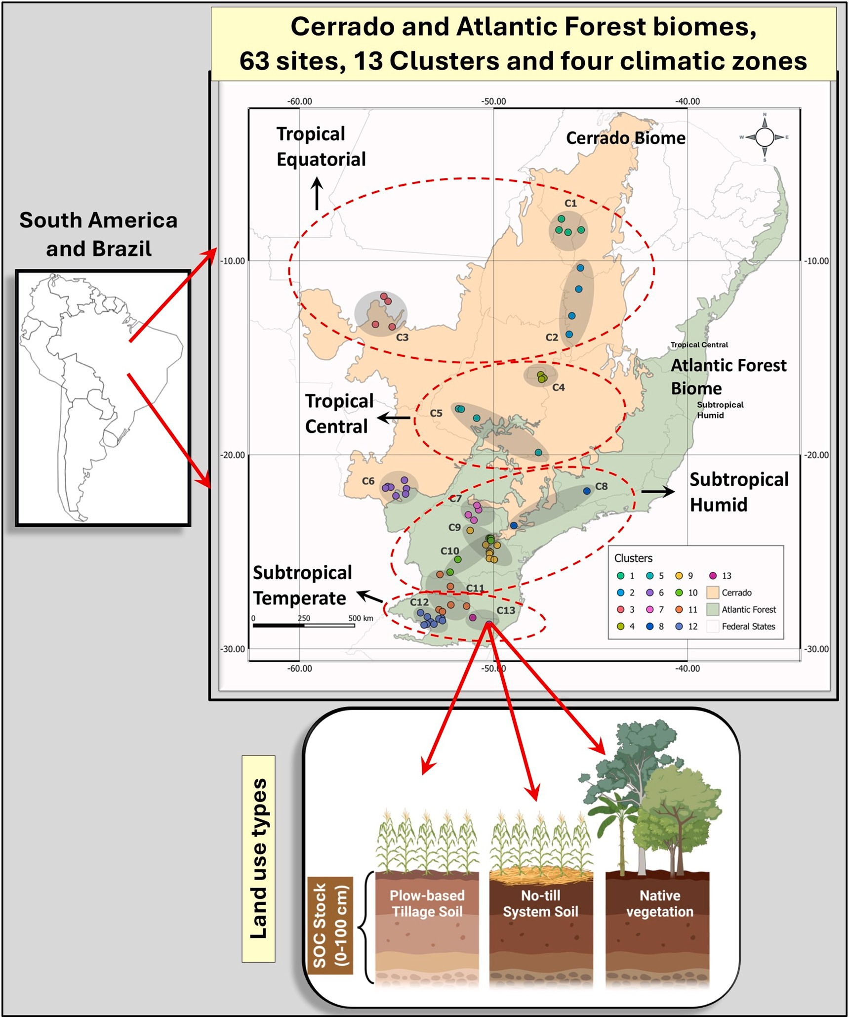

Fig. 1. Location of the 63 sites (26 sites in the Cerrado and 37 in the Atlantic Forest biome), 13 clusters (C1 to C13) represented by the shadow ellipses, four climate zones represented by the red dashed line and three land use types (Plow-based tillage-PBT, No-till system-NTS, Native vegetation-NV).

Table 1
Clusters (Edaphoclimatic Zones) designation and general information.
 | Clusters |  | Cluster |  | Sites |  | Latitude |  | Clusters Composition
 |  |  |  |  | per
 | Designation |  | ID |  | Cluster |  | (◦South) |  | Elevation Climate |  | Mean annual | Mean annual | Dry | Summer | Winter | Soil
 |  |  |  |  |  |  |  |  | (masl) classification, |  | temperature | precipitation | period |  |  | textural
 |  |  |  |  |  |  |  |  | Ko¨ppen |  | (◦C) | (mm) | per year |  |  | class
 |  |  |  |  |  |  |  |  |  |  |  |  | (months)
 | Tropical |  | C1 |  | 4 |  | 7 to 8 |  | < 300 Af, Cwb, Aw |  | 26.4 | 1096 | 6 | Hot | Hot | Sand-Clay
 | Equatorial Oriental
Tropical |  | C2 |  | 4 |  | 10 to 13 |  | 770–953 |  | Aw | 25.4 | 1201 | 6 to 7 | Hot | Mild | Sand-Clay
 | Equatorial
Zone
Equatorial/ |  | C3 |  | 4 |  | 11 to 13 |  | 352–472 |  | Aw | 25.5–26.1 | 1850 to 2150 | 4 to 6 | Hot | Hot | Clayey
Tropical
Center
Tropical Center |  | C4 |  | 3 |  | 15.9–16.1 |  | 885–1023 |  | Aw | 22.6 | 1028 | 6 to 7 | Hot | Mild | Clayey to
 |  |  |  |  |  |  |  |  |  |  |  |  |  |  |  | Very Clay
Tropical Center |  | C5 |  | 4 |  | 17.6–19.9 |  | 680–870 |  | Aw | 22.9 | 1158 to 1600 | 6 | Hot | Mild | Clayey
Tropical Center |  | C6 |  | 7 |  | 21 to 22 |  | 300–587 |  | Aw | 23.9 | 1110 to 1400 | 5 to 6 | Hot | Mild/ | Clayey
 |  |  |  |  |  |  |  |  |  |  |  |  |  |  | Cold
Subtropical |  | C7 |  | 4 |  | 21 to 23 |  | 374–476 |  | Aw | 22.9 to 23.4 | 1261 to 1400 | 5 to 6 | Warmer | Cold | Clayey
Humid
Subtropical |  | C8 |  | 3 |  | 22 to 23 |  | 108–873 |  | Cwb, Aw | 22.5 | 1215 to 1400 | No Dry | Warmer | Cold | Clayey
Humid |  |  |  |  |  |  |  |  |  |  |  |  | period
Subtropical |  | C9 |  | 7 |  | 23 to 25 |  | 820–1040 |  | Cfa | 17.6 to 18.3 | 1440 to 1490 | No Dry | Mild | Cold | Sand-Clay
Humid |  |  |  |  |  |  |  |  |  |  |  |  | period |  |  | To
 |  |  |  |  |  |  |  |  |  |  |  |  |  |  |  | Clayey
Subtropical |  | C10 |  | 6 |  | 24 to 26 |  | 960–1040 |  | Cfb | 18.8 | 1450–1700 | No Dry | Mild | Cold | Clayey
Humid |  |  |  |  |  |  |  |  |  |  |  |  | period
Subtropical |  | C11 |  | 6 |  | 26 to 28 |  | 650–870 |  | Cfb | 17.9–19.8 | 1700–1850 | No Dry | Mild | Cold | Sand-Clay
Humid |  |  |  |  |  |  |  |  |  |  |  |  | period | Cold |  | to Clayey
Subtropical/ |  | C12 |  | 9 |  | 28 |  | 380–510 |  | Cfb, Cfa | 18.34 | 1600–1850 | No Dry | Mild | Cold | Clayey
Temperate |  |  |  |  |  |  |  |  |  |  |  |  | period | Cold
Subtropical/ |  | C13 |  | 2 |  | 28 |  | 900–1080 |  | Cfb | 17.9 | 1600 to 1800 | No Dry | Mild | Cold | Clayey
Temperate |  |  |  |  |  |  |  |  |  |  |  |  | period | Cold

and land cover and contributes about 60 % of the total food production in Brazil.
The Atlantic Forest biome (Fig. 1 and Table 1) is characterized by a complex interaction with the ocean, encompassing a vast latitudinal (north – south) and altitudinal range. This results in an accumulation of moisture in the atmosphere at >1300 mm per year (Rezende et al.,
2018). Moreover, temperature declines with increase in altitude, with
annual mean of <12 ◦C in the high altitude areas. The annual rainfall is less than 700 mm in the northeast arid areas, compared with up to 2500
mm in the subtropical southern region of the country. The central humid subtropical region receives rainfall of 1000 and 1600 mm (Alvares et al., 2013). The MAT is strongly influenced by longitude and altitude, with extremes ranging from 8 to 29 ◦C (details in S´a et al. (2025)).

  - Land use types

Soil samples were obtained from each site for three categories of LUT, as described briefly below (S´a et al., 2025):

- Native vegetation (NV): the term “native vegetation” refers to a spe- cific vegetative community found in a given location representing an undisturbed soil. This LUT reflects the dynamic equilibrium of SOC.
- Plow-based tillage (PBT): This LUT has undergone substantial degra- dation due to recurrent and intensive soil disturbance, resulting from the utilization of disking and harrowing prior to the seeding of crops. This disturbance disrupts to soil structure and macroaggregates resulting in release of CO₂.
- No-till system (NTS): This LUT is predicated on a systemic approach characterized by the principles of the CA including the following: 1) absence of soil disturbance (restricted to the seeding row, 2) main- tenance of permanent soil cover, and 3) use of diversified crop ro- tations to enhance input of biomass-C. The selected farms were
managed according to the principles of CA and the duration of sites under continuous NTS varied from 18 to 49 years.

  - Soil sampling protocol

Soil samples were obtained according to the following protocol:

- Characterization of the farms and sampling point location: A template was developed for the collection of data on a range of environmental factors, including soil type, elevation, landscape characteristics, slope gradient, rainfall patterns, and temperature trends (details in Sa´ et al. (2025)).
- NTS plot selection and benchmark (Sa´ et al., 2025): The identification
of the NTS plots was achieved through an evaluation of each farm’s plots, which were maintained under a long-term NTS. The selected NTS plot was situated in proximity to an area under NV and had the same soil type and textural class as that of the NTS. The PBT land use was selected in close proximity to the NTS and NV sites, with a maximum distance of 10 km within the same microclimate. The soil type and textural class were aligned to those of NTS and NV sites to ensure consistency in the soil characteristics.
- Benchmark and excavation of trenches: The selection of the benchmark for soil sampling was made on the basis of three criteria: firstly, variations in the percentage of slope; secondly, the soil type present within a given field; and thirdly, textural class. Each benchmark was represented by a pseudo-replicate, designated hereinafter as Trench 1, 2, and 3 (details in Sa´ et al. (2025)).
- Soil sampling:
Soil sampling was performed from April 2023 to May 2024 in accordance with the crop calendar and precipitation patterns. Disturbed and undisturbed samples were obtained from each trench at six depths (0–10, 10–20, 20–40, 40–60, 60–80, and 80–100 cm),

comprising 3402 bulk samples and 3402 undisturbed core samples (i. e., 03 LUT × 03 replicates × 06 depths × 63 sites = 3402 samples). (S´a et al., 2025) A total of 3402 cores samples, were obtained by a core sampler (each steel ring measuring 5 cm in height and diam- eter), for the purpose of determining the soil bulk density (S´a et al., 2025).

  - Soil carbon analysis

The SOC concentration was determined by the dry combustion method with a CN elemental analyzer (LECO 832 Series Combustion, St. Joseph, MI 49085, USA) on samples sieved through a 2-mm mesh and dried in an oven at 40 ◦C (details in Sa´ et al. (2025)).

  - Soil organic carbon stock calculations

The SOC stock for each soil layer was calculated by the equivalent soil mass (ESM) method proposed by Ellert and Bethany (Ellert and Bettany, 1995; Ellert et al., 2001) and further adjusted following the procedures outlined in a recent publication (Sa´ et al., 2025). The rationale was to utilize the soil layers under NV as the reference for accounting for the ESM in the PBT and NTS, as these represent the natural and undisturbed soil condition. This approach was deemed appropriate given that the soil layers under NV represent the baseline or natural state of soil (S´a et al., 2025).

  - Emissions and mitigation calculation

- The SOC emissions by PBT accounted for 0–100 cm:
NV SOC stock - PBT SOC stock, in Mg C ha^{—1}. The SOC stock loss for 0–100 cm layer is the sum of all depths sampled to represent the
total loss to 1-m depth. The quantity of SOC stock that was lost was converted to CO₂e by multiplying the SOC stock by a factor of 3.67, which was obtained by determining the atomic mass of CO₂. The molecular formula for carbon dioxide is C = 12, O = 16, and the
molecular weight of carbon dioxide is 44. The ratio of 44 (CO₂ mass) to 12 (C mass) is 3.67.
- The SOC mitigation (in Mg CO₂e ha^{—1}) was calculated as follows:
NTS SOC stock – PBT SOC stock for each layer was computed for each site. The SOC to 1-m depth was computed by summing the value for each depth sampled. The data obtained for each cluster was subsequently converted into CO₂e, as previously outlined.
    - Land area under no-till systems and uncertainty approach
The surface area of each farm in the NTS was obtained directly from the respective owner. The area for each cluster was subsequently determined by calculating the sum of the surface areas of each farm. The total surface area under NTS for all clusters, totaling 86,411 ha, is summarized in Table 2.

    - Rationale for net zero and net negative emissions for agricultural production systems
The conceptualization of net zero agriculture involves achieving a balance between the amount of greenhouse gases (GHGs) produced and the amount removed from the atmosphere, thereby contributing to a negligible impact on climate change. Net negative emissions refer to a scenario in which the removal of CO₂ exceeds the net zero level by land- use and management guiding to net C storage into the soil (Fig. 2).
The calculation of net zero and net negative emissions in this study was based on the following protocol:

- The first step involves the conversion of the measured C sequestra- tion rate for each cluster into the equivalent biomass-C. This calcu- lation is based on the quantity of C present in the biomass added to the soil that has been converted into SOC. For the tropical region specifically, the percentage of C from biomass converted into SOC has been documented as 20.5 % (Sa´ et al., 2015). The conversion factor obtained through dividing 100 by 20.5, resulting in a quotient of 4.878 (Sa´ et al., 2015). In subtropical regions, the biomass-C conversion rate is 19.0 %, and the factor is calculated as 100 divided by 22.9, yielding a value of 5.263.
- The second step involves estimating the amount of C required to achieve the net zero based in previous finding (de Oliveira Ferreira et al., 2012; Sa´ et al., 2015). For tropical regions the minimum amount of biomass-C to reach the dynamic equilibrium or net zero is
5.5 Mg C ha^{—1} yr^{—1} (Sa´ et al., 2015) and for subtropical regions it was
4.15 Mg C ha^{—1} yr^{—1} (de Oliveira Ferreira et al., 2012; Sa´ et al., 2015).
- Thirdly, the net negative C value was obtained through diminishing the C equivalent to sequestration rate by 5.5 Mg C ha^{—1} yr^{—1} (amount of biomass-C for net zero).
- Example for Cluster 1:
SOC sequestration rate for C1 = 1.53 Mg C ha^{—1} yr^{—1} × 4.787 =
7.46 Mg C ha^{—1} yr^{—1}, that represents the amount of biomass-C added to obtain the sequestration rate of 1.53 Mg C ha^{—1} yr^{—1}.

Net negative C = 7.46 Mg C ha^{—1} yr^{—1}-5.5 Mg C ha^{—1} yr^{—1} (minimum amount of C to reach net zero) = 1.96 Mg C ha^{—1} yr^{—1}.

Table 2
Crop-land area under no-till systems (NTS) for each climate zone, means of SOC stock (0–100 cm) per land use type (LUT) and per Cluster, percentage of uncertainty for SOC stock (1-m depth) of each LUT, SOC stock adjusted for uncertainty and converted to CO₂e.
Climate zone | Clusters | Crop-land area under NTS  (ha) | Mean of SOC Stock for 0–100 cm  (Mg C ha^{—1})  NV NTS |  | % of Uncertainty  PBT NV NTS |  |  | SOC Stock adjusted for % uncertainty  (Mg C ha^{—1})  PBT NV NTS PBT |  |  |  | SOC stock converted to CO₂e  (Mg CO₂e ha^{—1})  NV NTS PBT
Tropical | 1 | 14,924 | 113.3 | 106.0 | 72.2 | 6.3 | 2.7 | 2.7 | 106.1 | 103.2 | 70.3 | 389.5 | 378.7 | 258.0
Equatorial | 2 | 23,000 | 92.7 | 90.3 | 72.5 | 3.6 | 3.6 | 2.5 | 89.3 | 87.0 | 70.7 | 327.8 | 319.4 | 259.5
 | 3 | 12,150 | 147.7 | 156.3 | 110.4 | 4.6 | 5.2 | 6.8 | 140.9 | 148.1 | 102.8 | 516.9 | 543.6 | 377.4
Tropical | 4 | 3174 | 237.4 | 183.5 | 142.9 | 5.4 | 2.4 | 3.0 | 224.5 | 179.1 | 138.6 | 823.9 | 657.2 | 508.6
Central | 5 | 4839 | 219.4 | 203.5 | 128.3 | 8.9 | 2.2 | 5.5 | 199.8 | 199.0 | 121.2 | 733.2 | 730.3 | 444.9
 | 6 | 3972 | 196.9 | 148.8 | 96.8 | 7.3 | 4.4 | 9.2 | 182.6 | 142.2 | 88.0 | 670.0 | 521.9 | 322.8
Subtropical | 7 | 1177 | 187.6 | 157.3 | 115.1 | 2.5 | 8.5 | 5.7 | 182.9 | 143.9 | 108.6 | 671.3 | 528.3 | 398.5
Humid | 8 | 2020 | 184.2 | 165.7 | 102.1 | 15.1 | 5.6 | 3.7 | 156.5 | 156.5 | 98.4 | 574.2 | 574.5 | 361.1
 | 9 | 3068 | 209.8 | 181.9 | 113.2 | 6.5 | 6.9 | 7.8 | 196.2 | 169.2 | 104.4 | 719.9 | 621.1 | 383.1
 | 10 | 1735 | 264.9 | 236.2 | 139.8 | 7.5 | 11.1 | 7.0 | 244.9 | 209.9 | 129.9 | 898.9 | 770.2 | 476.7
 | 11 | 2555 | 272.7 | 198.4 | 144.6 | 11.2 | 9.6 | 11.7 | 242.1 | 179.4 | 127.7 | 888.6 | 658.2 | 468.7
Subtropical | 12 | 7707 | 180.9 | 153.3 | 113.4 | 4.4 | 3.6 | 4.4 | 173.0 | 147.8 | 108.4 | 635.0 | 542.2 | 397.8
Temperate | 13 | 6090 | 201.3 | 177.4 | 98.9 | 12.1 | 11.1 | 17.1 | 176.9 | 157.7 | 82.0 | 649.1 | 578.7 | 300.9
Total NTS surface area |  | 86,411

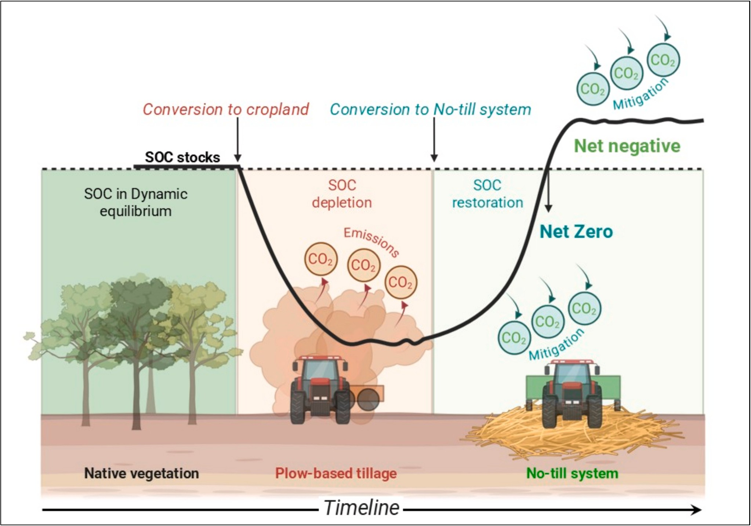

Fig. 2. The theoretical model illustrates the soil organic carbon (SOC) dynamics equilibrium state of native vegetation. The sequence shows the conversion of native vegetation into cropland in conjunction with the continuous use of plow-based tillage, as key factor to cause SOC depletion. The transition to no-till systems (NTS) demonstrate the SOC restoration and achieves SOC dynamic equilibrium, thereby representing net zero emissions. The maintenance of long-term NTS is the step forward to promoting net negative emissions over time.

The percentage of net zero and the net negative C emissions was computed according to the following expression:

  - Net zero C = [(5.5 Mg C ha^{—1} yr^{—1} × 100)]/7.46 Mg C ha^{—1} yr^{—1} =
73.7 %
  - Net negative C = [1.96 Mg C ha^{—1} yr^{—1} × 100)]/7.46 Mg C ha^{—1} yr^{—1}
= 26.27 %

The percentage of net zero and Net negative C of each cluster were used to calculate the total net zero and Net negative emissions for each cluster shown in Figs. 1 and 2.
2.7 Rationale of Clusters (Edaphoclimatic zones) and environmental covariates.
The cluster approach is conceptually defined as a group of similar items that occur together (Fig. 1). The clustering algorithm chosen for this study is referred to as Spectral Clustering (von Luxburg, 2007) due to its higher efficiency in identifying complex patterns within the datasets. Spectral algorithm package (von Luxburg, 2007) was used for its ability to analyze the spatial variability of environmental covariates, including soil type, soil texture, MAP and MAT patterns, elevation, slope gradient, and land cover coded as C1 to C13 (Fig. 1). It operates by transforming the data into a lower dimensional space by applying dimensionality reduction methods such as Laplacian Eigenmaps where the clusters are more discernible and differ from the traditional methods such as K-means or hierarchical clustering. In this study, a clustering approach was used to assess environmental variables data spanning 63 distinct geolocations over a seven-year period (Fig. 1). The objective was
to infer similarities and groupings among these geolocations based on their environmental profiles, along with geographic information such as coordinates and elevation, in order to define edaphoclimate zones. The normalization was achieved through the use of the Standard Scalar (von Luxburg, 2007) function from the scikit-learn Python library, which standardizes the scales across all features. Following the completion of the cluster analysis, each geolocation was assigned to a specific cluster based on the degree of similarity observed among its environmental and geological attributes (Sa´ et al., 2015). The clustering process enabled the identification of discrete geographical groups (referred to as clusters hereafter) that facilitated to infer trends and variations in the environ- mental characteristics.
The present study identified six clusters within the Cerrado biome, three of which (i.e., C1 to C3) are situated within the tropical-equatorial climate zone, and the other three (i.e., C4 to C6) within the Tropical Central zone. Additionally, seven clusters are identified in the Atlantic Forest biome, comprising five within the subtropical humid zone (i.e., C7 to C11) and two within the subtropical temperate zone (i.e., C12 and C13) (Fig. 1).

Statistical analysis

  - The uncertainty of the extrapolation of soil organic C stock and CO₂e emissions

The calculation of uncertainty is achieved through the utilization of the standard error formula (Ellison and Williams, 2012), which

quantifies the variability or uncertainty in a sample mean estimate. The standard error (SE) is derived by dividing the standard deviation (SD) of the sample by square-root of the sample size (n). It provides insight into the extent of expected variation between the sample mean and the true population means. The SE of the mean quantifies how much the sample mean is expected to vary from the true population meaning. The calculation of uncertainty % for SOC stock of each cluster was according to the following expression (Ellison and Williams, 2012):
(standard error)

Results

  - Magnitude of CO₂e emissions by plow-based tillage

The investigation revealed a broad range of CO₂e emissions across the climate zones, with the lowest value of 74.2 Mg CO₂e ha^{—1} (i.e.,
cluster 2) in the equatorial tropical climate zone to the highest of 470.1 Mg CO₂e ha^{—1} (i.e., cluster 11) in the subtropical humid climate zone (Fig. 3). The most substantial levels of CO₂e emissions were observed in

Uncertainty% =
mean
× 100
the subtropical humid zone where the soils accumulated more C in the 0–100 cm layer and is characterized by an absence of prolonged dry

In this study, we employed the % uncertainty to estimate the maximum attainable value of SOC stock within each cluster. Specif- ically, we subtracted the calculated percentage uncertainty from the measured SOC stock for each cluster to define its upper boundary. The uncertainty values applied in the calculations of emissions and mitiga- tion were based on the PBT and NTS sites. The percentage (%) of un- certainty values for NTS and PBT of each cluster are summarized in Table 2:
The final SOC stock and the conversation to CO₂e were based on the adjustment of the SOC stock limited by the % of uncertainty, according to the example as follow:
For the cluster 1 (C1) the % of uncertainty determined was 2.7 %, and the SOC stock was 106.0 ± 8.86 Mg C ha^{—1} for 0–100 cm depth. SOC stock adjusted = 106 [106 × 2.7)/100] = 97.14 Mg C ha^{—1}
To assess the relationship between Ca and SOC stock, a linear regression analysis was conducted with Ca as the dependent variable and SOC stock as the independent variable.

3.2. Selection and preprocessing of environmental covariates

A set of environmental covariates was compiled to characterize soil and landscape properties relevant to the study areas. These covariates included topographic and climatic variables commonly used in digital soil mapping and environmental modeling. All covariates were resam- pled to a consistent spatial resolution (30 m).
Prior to model fitting, all covariates were screened for multi- collinearity using the Variance Inflation Factor (VIF). Continuous covariates were standardized (z-score transformation) to facilitate comparison of variable effects (Breiman, 2018).

3.3. Random forest and variable importance ranking

To assess the relative influence of each covariate on the target soil property (SOC), a Random Forest (RF) model was implemented using the random Forest package (Breiman, 2018). The response variable was the measured or estimated soil attribute of interest (SOC), and the pre- dictor set comprised the preprocessed environmental covariates.
Random Forest is a non-parametric ensemble learning method that constructs a large number of decision trees using bootstrapped samples of the training data and random subsets of predictors at each split (Breiman, 2001). The final prediction is obtained by averaging or clas- sifying across all trees. Model hyperparameters, such as the number of trees (ntree) and number of variables sampled at each split (mtry), were optimized via grid search and 10-fold cross-validation to improve model accuracy and stability.
Variable importance was quantified using the mean decrease in ac- curacy (MDA) and mean decrease in Gini impurity (MDG) metrics computed during model training. MDA measures the reduction in model accuracy when the values are permuted, indicating how strongly the model depends on that variable. MDG reflects the total reduction in node impurity attributable to a variable across all trees in the forest. The environmental covariates were ranked in descending order based on their standardized importance scores.
periods (Sa´ et al., 2025). Conversely, the tropical central, in conjunction
with the subtropical temperate and tropical equatorial zones, demon- strated the lowest levels of CO₂e emissions (Fig. 3).
The clusters with the highest emissions levels were C10 and C11, which are in the subtropical humid climate zones with clayey texture class. In contrast, the lowest levels of emissions were observed in clusters C1, C2, and C3, which are situated within the tropical equatorial region in sandy-clay soils, except C3 that was characterized of soils with a clayey texture.
The total CO₂e emissions in the tropical equatorial climate zone (i.e., sum of emissions from clusters C1 to C3) were calculated to be 5.51 Tg CO₂e, 3.88 Tg CO₂e for tropical central (i.e., Clusters C4 to C6), 3.21 Tg CO₂e for subtropical humid (i.e., Clusters C7 to C11), and 4.2 Tg CO₂e at subtropical temperate (i.e., Clusters C12 and C13) climate zones, with a cumulative total of 16.80 Tg CO₂e.
The environmental co-variables (Eco-V) had a large effect on these emissions (Fig. 4). In the tropical equatorial region, the most salient Eco- V for C1 was total precipitation and mean annual temperature (MAT), while for C2 the impact Eco-V sequence was: clay = mean relative hu- midity = MAT greater than those of total precipitation = mean annual precipitation and for C3, the primary Eco-V ranked were clay content, mean solar irradiation (MSI) and Total precipitation. Nevertheless, for the tropical central climate zone (C4, C5, and C6), the primary Eco-V factors were mean solar radiation, clay content, MAT, and elevation. Conversely, in the subtropical humid zone, the covariates that exerted the most significant influence were ranked as follows: elevation, MAT, clay content and total precipitation. Moreover, the ranking of Eco-V in the subtropical temperate region was as follows: (1) maximum average temperatures, (2) average annual temperatures, and (3) total precipi- tation (Fig. 4).

  - Farming soil C by no-till Systems (NTS)

The total surface area of the 63 sites (Table 2) under NTS amounted to 86,411 ha (ha). The clusters situated in the tropical equatorial climate zones accounted for the largest surface area (i.e., 50,074 ha) followed by subtropical temperate (13,797 ha), tropical central (11,985 ha) and subtropical humid (10,555 ha).
The SOC stock build-up at the 0–100 cm depth level refers to the sum total of the SOC stocks present within the 0–100 cm layer of each farm within each respective cluster. In the equatorial tropical zone (C1 to C3), the SOC stock was 1.47 Tg, while in the central tropical zone (C4 to C6), it was 0.70 Tg. In the humid subtropical zone (C7 to C11), the total amounted to 0.73 Tg, while in the temperate subtropical zone (C12 and C13), it reached 0.79 Tg.
The distribution of mitigation within the soil profile was 56 % in the 0–40 cm layer and 44 % in the 40–100 cm layer for the Cerrado biome, as compared with 53.7 % and 46.4 % in the 0–40 cm and 40–100 cm layers, respectively, for the Atlantic Forest biome (Sa´ et al., 2025).
The total SOC stock to 0–100 cm depth calculated as a sum of the 13 clusters across 86,411 ha, was 3.68 Tg C, equivalent to 13.52 Tg CO₂e.

  - Net zero and net negative emissions by NTS

The biomass-C equivalent to the sequestration rates exhibited a

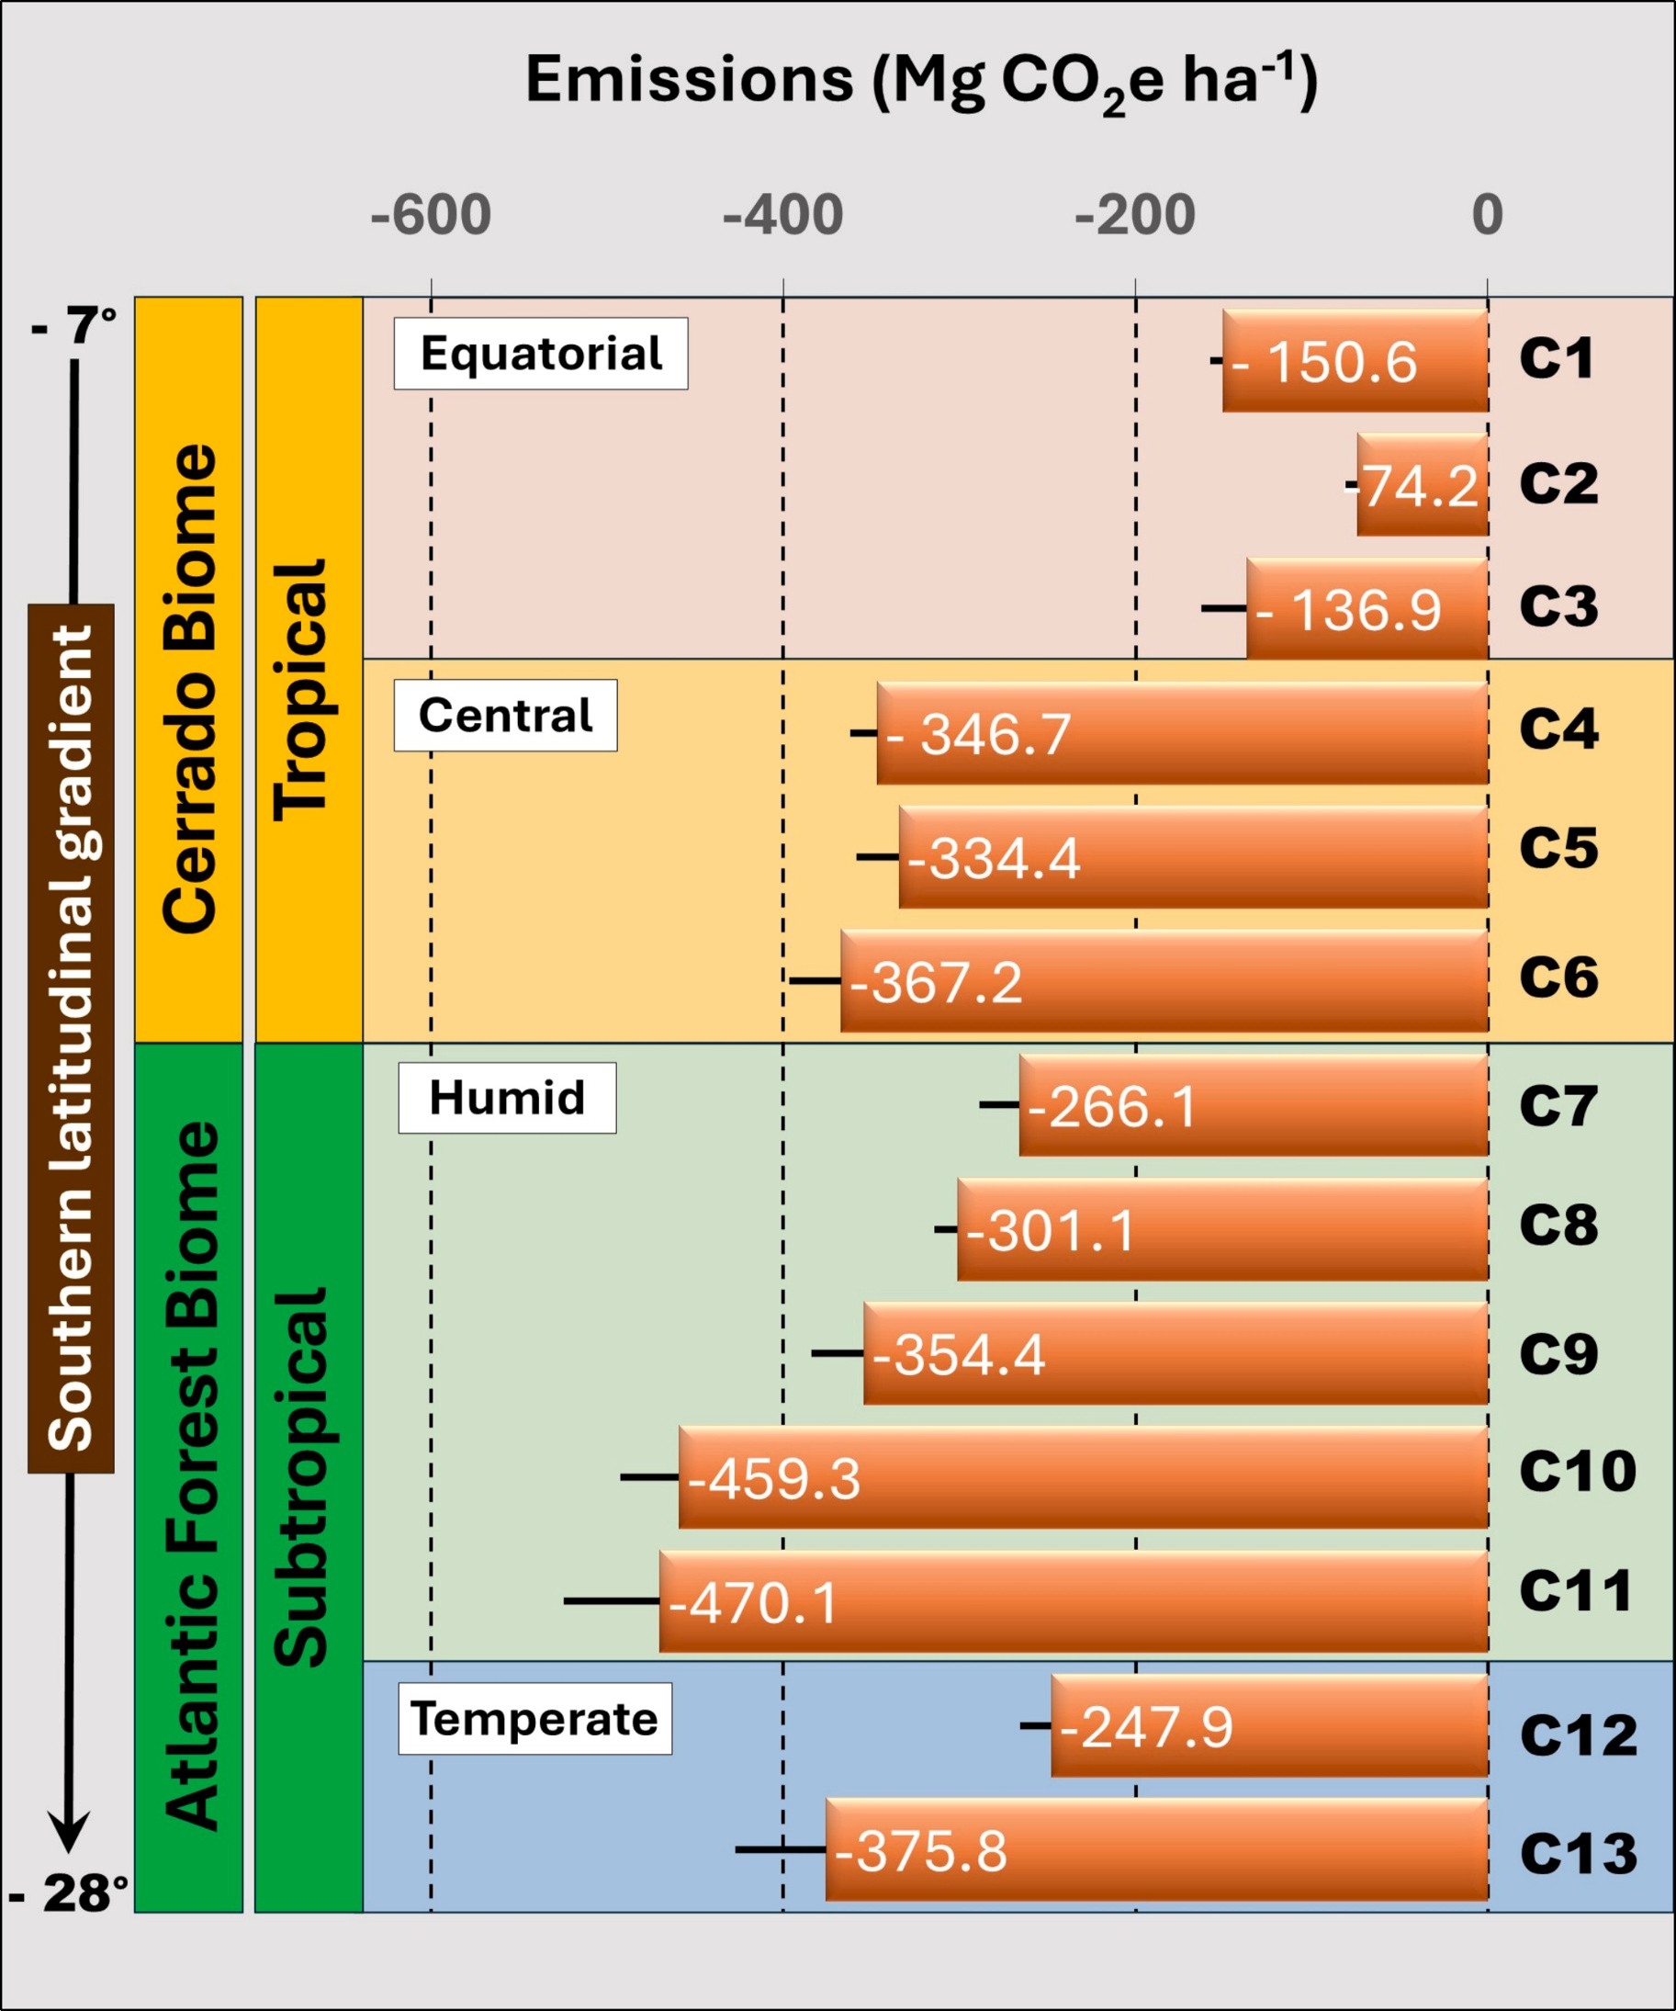

Fig. 3. The impact of continuous plow-based tillage (PBT) on soil carbon dioxide equivalent (CO₂e) emissions in four climate zones within the Cerrado and Atlantic Forest biomes. The calculation of CO₂e emissions is derived from the difference between the NV SOC stock and the PBT SOC stock for the 0–100 cm layer and this data was subsequently converted into CO₂e units.

considerable range, from 5.9 Mg C ha^{—1} yr^{—1} (i.e., a sequestration rate of 1.21 Mg C ha^{—1} yr^{—1}) for the C2 within the tropical equatorial climate zone to 13.2 Mg C ha^{—1} yr^{—1} (i.e., a sequestration rate of 2.50 Mg C ha^{—1} yr^{—1}) in the C10 at the subtropical humid climatic zone (Table 3). Nevertheless, the quantity of biomass-C input exceeded the minimum level required to achieve dynamic C equilibrium (equivalent to Net Zero) across all clusters. In the subtropical region, negative net emis- sions were greater than those observed in the tropical region (Fig. 5).

Discussion

  - Net zero and net negative emissions of tropical and subtropical agroecosystems

The amount of biomass-C input per hectare (ha) required to achieve net zero emission was estimated at 5.5 Mg C ha^{—1} yr^{—1} (Sa´ et al., 2015) for tropical equatorial and tropical central conditions compared with
4.36 Mg C ha^{—1} yr^{—1} (de Oliveira Ferreira et al., 2012; de Oliveira Fer- reira et al., 2021) for subtropical humid and temperate conditions

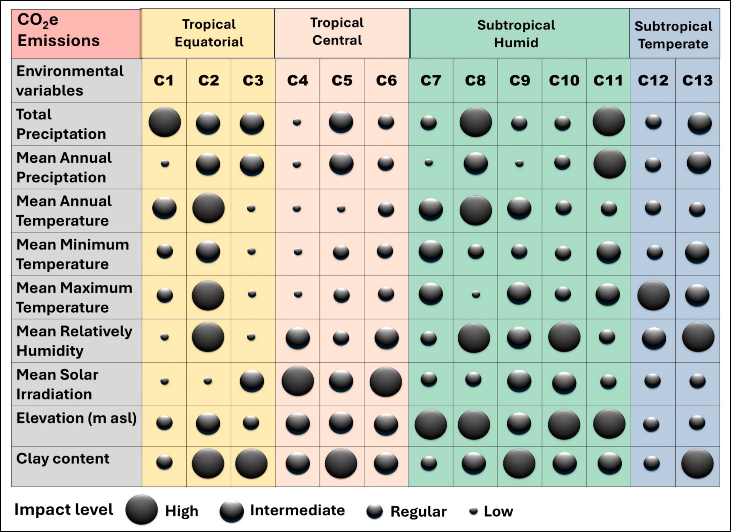

Fig. 4. Rank of environmental co-variables impacts in the CO₂e emissions by plow-based tillage (PBT) in the 13 clusters (C1 to C13) in four climate zones (tropical equatorial and central, subtropical humid and temperate) within the Cerrado and Atlantic Forest biomes.

Table 3
Average of annual biomass-C input equivalent (Mg C ha^{—1}) to the soil organic carbon (SOC) sequestration rate for each Cluster (C1 to C13).
Biomes | Climatic Zone | Clusters | SOC Sequestration rates § | Biomass-C equivalent to sequestration rates : | Minimum amount of Biomass-C input to reach Net Zero | Net negative Emissions
Cerrado | Tropical Equatorial | C1 | 1.53 | 7.47 | 5.5 | 2.0
 |  | C2 | 1.21 | 5.90 | 5.5 | 0.4
 |  | C3 | 1.99 | 9.70 | 5.5 | 4.2
 | Central | C4 | 1.66 | 8.10 | 5.5 | 2.6
 |  | C5 | 2.49 | 12.15 | 5.5 | 6.6
 |  | C6 | 1.88 | 9.18 | 5.5 | 3.7
Atlantic | Subtropical Humid | C7 | 1.49 | 7.89 | 4.15 | 3.7
Forest |  | C8 | 1.84 | 9.7 | 4.15 | 5.6
 |  | C9 | 1.72 | 9.1 | 4.15 | 5.0
 |  | C10 | 2.50 | 13.2 | 4.15 | 9.1
 |  | C11 | 1.47 | 7.8 | 4.15 | 3.6
 | Temperate | C12 | 1.14 | 6.0 | 4.15 | 1.9
 |  | C13 | 1.89 | 10.0 | 4.15 | 5.8
§ Obtained by the linear regression between NTS duration time (years) and soil organic carbon sequestered (Mg C ha^{—1} yr^{—1});
: Involves the conversion of the measured C sequestration rate for each cluster into the equivalent biomass-C. For the tropical region specifically, the percentage of C from biomass converted into SOC was 20.5 % and 19.0 % for subtropical (see topic: Rationale for Net Zero and Net Negative Emissions). Example for cluster 1: SOC sequestration rate = 1.53 Mg C ha^{—1} yr^{—1} × 4.787 = 7.46 Mg C ha^{—1} yr^{—1}.

(Table 3; Fig. 6). In this context, the amount of biomass-C added through NTS fulfilled the net zero requirements and exhibited a net negative effect across all clusters (Table 3). Furthermore, a high rate of biomass-C input was estimated for clusters C5, C8, C9, C10, and C13, thereby endorsing intensification of the previously implemented crop rotation.
These results imply that negative emissions can be achieved when the management can lead to the required biomass-C input, the diversifica- tion of the quality of biomass added, and provide an optimal frequency of biomass input (Fig. S1). The validity of this claim was further sup- ported by the observation of net negative emissions across all clusters,

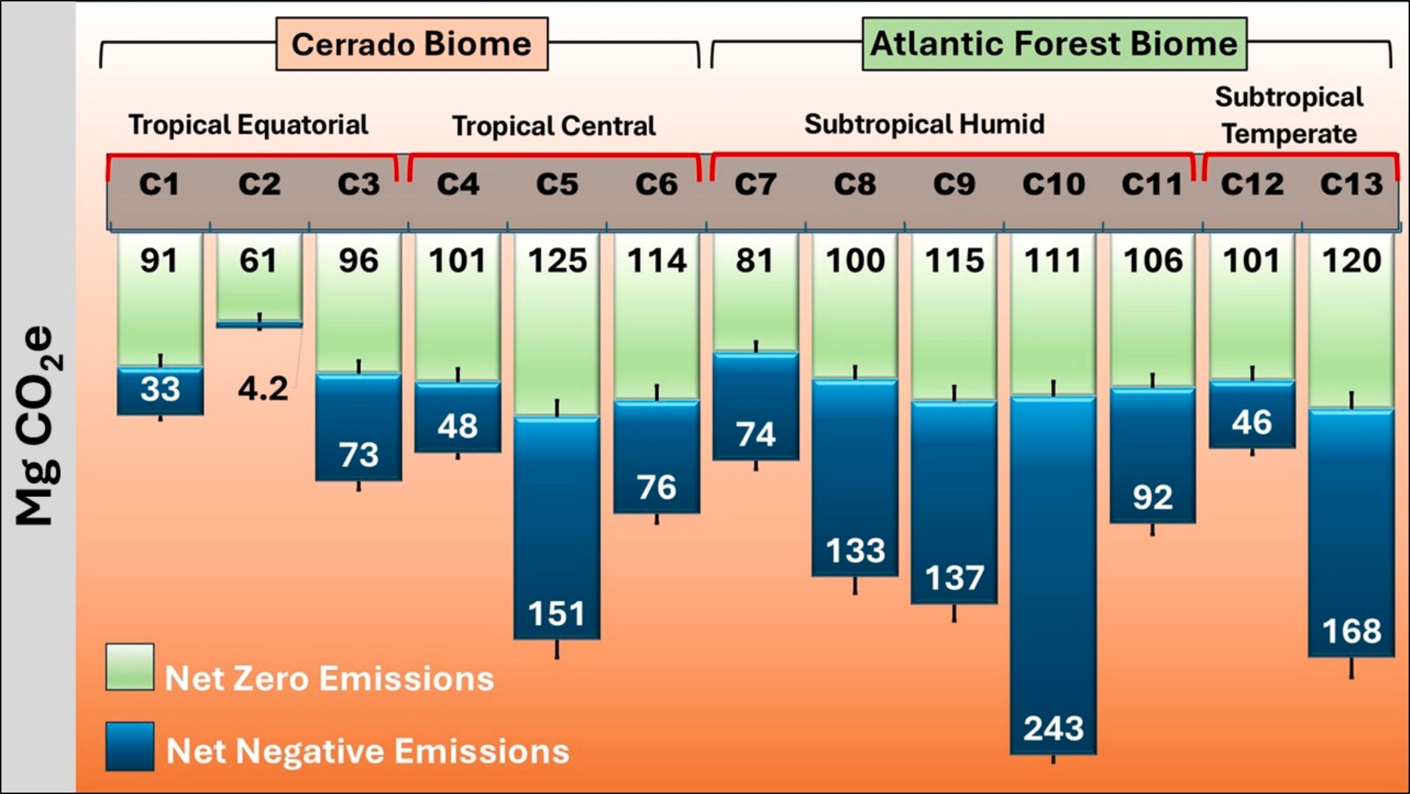

Fig. 5. Net zero and net negative emissions of CO₂e by no-till systems (NTS) for each cluster based on the difference between NTS SOC stock and PBT SOC stock for 1- m depth (SOC stock transformed into CO₂e) into four climate zones within the Cerrado and Atlantic Forest biomes. The heavy black dash within the bars refers to the quantity of Mg CO₂e due to the % of uncertainty for each cluster.

thereby establishing a definitive relationship between NTS and the achievement of net negative emissions (Fig. 5). A substantial amount of scientific literature has emerged that documents the efficacy of NTS practices to accumulate C into the soil in tropical and subtropical regions (Bayer et al., 2006; Boddey et al., 2010; Corbeels et al., 2006; Ferreira et al., 2020; Jantalia et al., 2007; Miranda et al., 2016; Sa´ et al., 2001; Sa´ et al., 2015).
The findings of these studies indicate that when the biomass-C input
is higher than that of net zero C levels, the soil becomes a C sink and achieves net negative emissions (Lal, 2021). Therefore, when long-term NTS is associated with high biomass-C input, it is reasonable to hy- pothesize that NTS can result in net negative emissions (Fig. 6).
The percentage of net zero emissions across all clusters varied ac- cording to the latitudinal gradient.
In the equatorial tropical climate zone, 74.5 % of CO₂ mitigation corresponded to net zero emissions, while 25.5 % was associated to net

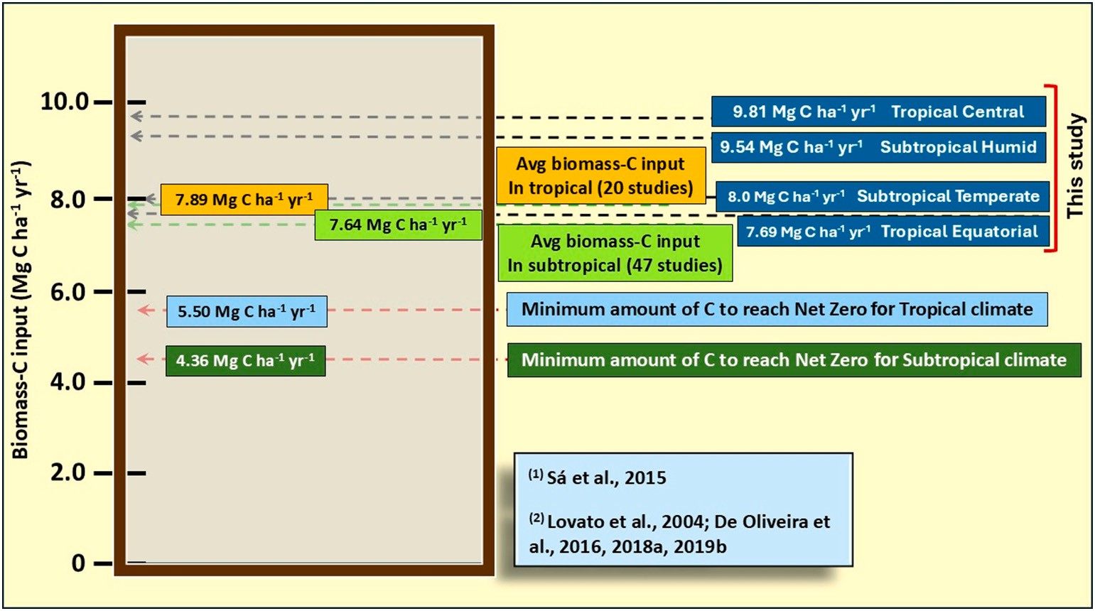

Fig. 6. The minimum amount of biomass-C to be added (both above and below ground) in order to achieve SOC dynamic equilibrium in the tropical and subtropical climate zones has been determined on the basis of articles published in Brazil (highlighted in blue light and green dark). The quantity of biomass-C introduced by NTS systems, as determined by this study (**), is displayed for the equatorial and central tropical and humid and temperate subtropical climate zones. ⁽¹⁾ (Sa´ et al., 2015);
⁽²⁾ (de Oliveira Ferreira et al., 2012, 2021; Lovato et al., 2004; Sa´ et al., 2015)

negative emissions.
Conversely, the percentage of mitigation related to net zero emission exhibited a downward trend in the other climate zones. The recorded percentages in the tropical central, subtropical humid, and subtropical temperate zones were 57.7 %, 45.2 %, and 55.1 %, respectively.
Overall, 58.6 % of mitigated values are recorded as net zero and range from 60.8 Mg CO₂e ha^{—1} (cluster C2) to 125.0 Mg CO₂e ha^{—1} for cluster C5 (Fig. 5). However, net zero C level did vary less between clusters (Fig. 5).
In six of the 13 clusters examined, CO₂e offset emissions were found to be statistically indistinguishable, suggesting that they did not exhibit differences across climate zones (Fig. 7). The offsetting was allocated to C1, C2, C3, C8, C10, and C13. NTS demonstrated a capacity for CO₂ emissions restoration by NTS, achieving 5.40 Tg CO₂e and restoring 98
% of the total emissions due PBT in the tropical equatorial region. The subtropical humid zone exhibited a restoration of 2.67 Tg CO₂e (i.e., 83.2 %), followed by the subtropical temperate zone at 2.88 Tg CO₂e (i. e., 68.7 %). The tropical central zone also displayed a restoration, reaching 2.57 Tg CO₂e that is equivalent to 66.1 % of emission sequestered in soil.
In the context of CO₂ mitigation, a more consistent pattern was observed. Precipitation, mean annual temperature, and mean solar irradiation appeared as dominant drivers across nearly all clusters, often with high or intermediate impact levels. Furthermore, relative humidity and elevation have been identified as crucial factors, particularly within tropical equatorial and subtropical temperate regions. In contrast to emissions, mitigation outcomes are influenced by a broader range of variables, suggesting that multiple environmental factors interact to enhance C sequestration potential (Fig. 8).
The cultivation of C4 plants, such as grasses, in regions with distinct precipitation patterns can be a contributing factor to this phenomenon. These plants exhibit a pronounced response to precipitation and tem- perature, which is evident in their ability to thrive in specific soil cover conditions (Sa´ et al., 2025). The most salient variables in the dataset
were found to be the mean total precipitation, mean average relative humidity, and mean solar radiation intensity. Within the specified cli- matic zone, particularly the C1 and C2 clusters, soils characterized by a predominant sandy-clay texture require a higher amount of water to accumulate dry mass (Table 2).
It has been observed that the transition zone delineated by the intersection of the Amazon and Cerrado biomes, designated as Cluster - C3, experiences elevated levels of precipitation, characterized by a precipitation volume range of between 1850 and 2150 mm.
Conversely, within the central tropical zone (comprising clusters C4, C5, and C6), three environmental variables emerged as key contributors to the performance of C accumulation: clay content, altitude, and mean annual temperature. Furthermore, mean annual precipitation and mean solar radiation intensity contributed to the observed phenomenon. This observation assumes particular relevance in the C4 and C5 clusters, which are situated at elevations exceeding 650 m above sea level (asl). These elevated regions are characterized by a temperate winter climate (Fig. 8 and Table 1).
The mitigation of 276 Mg CO₂e in C5 serves to reinforce this asser- tion. The clayey to very clayey soil texture is conducive to greater C accumulation.
Within the domain of the humid subtropical climate zone, delineated by clusters 7 to 11, the prevailing characteristic is the marked cold and humidity experienced during winter, with no evident rainfall re- strictions during this period (Fig. 8 and Table 1). This phenomenon enables a reduced rate of C decomposition, thereby ensuring enhanced protection of C. The climatic variables that exert the most pronounced influence on C accumulation include: (a) average annual precipitation, average relative humidity, altitude, and clay content.
In the temperate subtropical climate zone, clay content, average annual temperature, average annual and total precipitation exhibited the greatest influence on the ranking of climate variables. The envi- ronmental covariates that regulate soil C accumulation are predomi- nantly influenced by clay content, mean maximum temperatures, mean

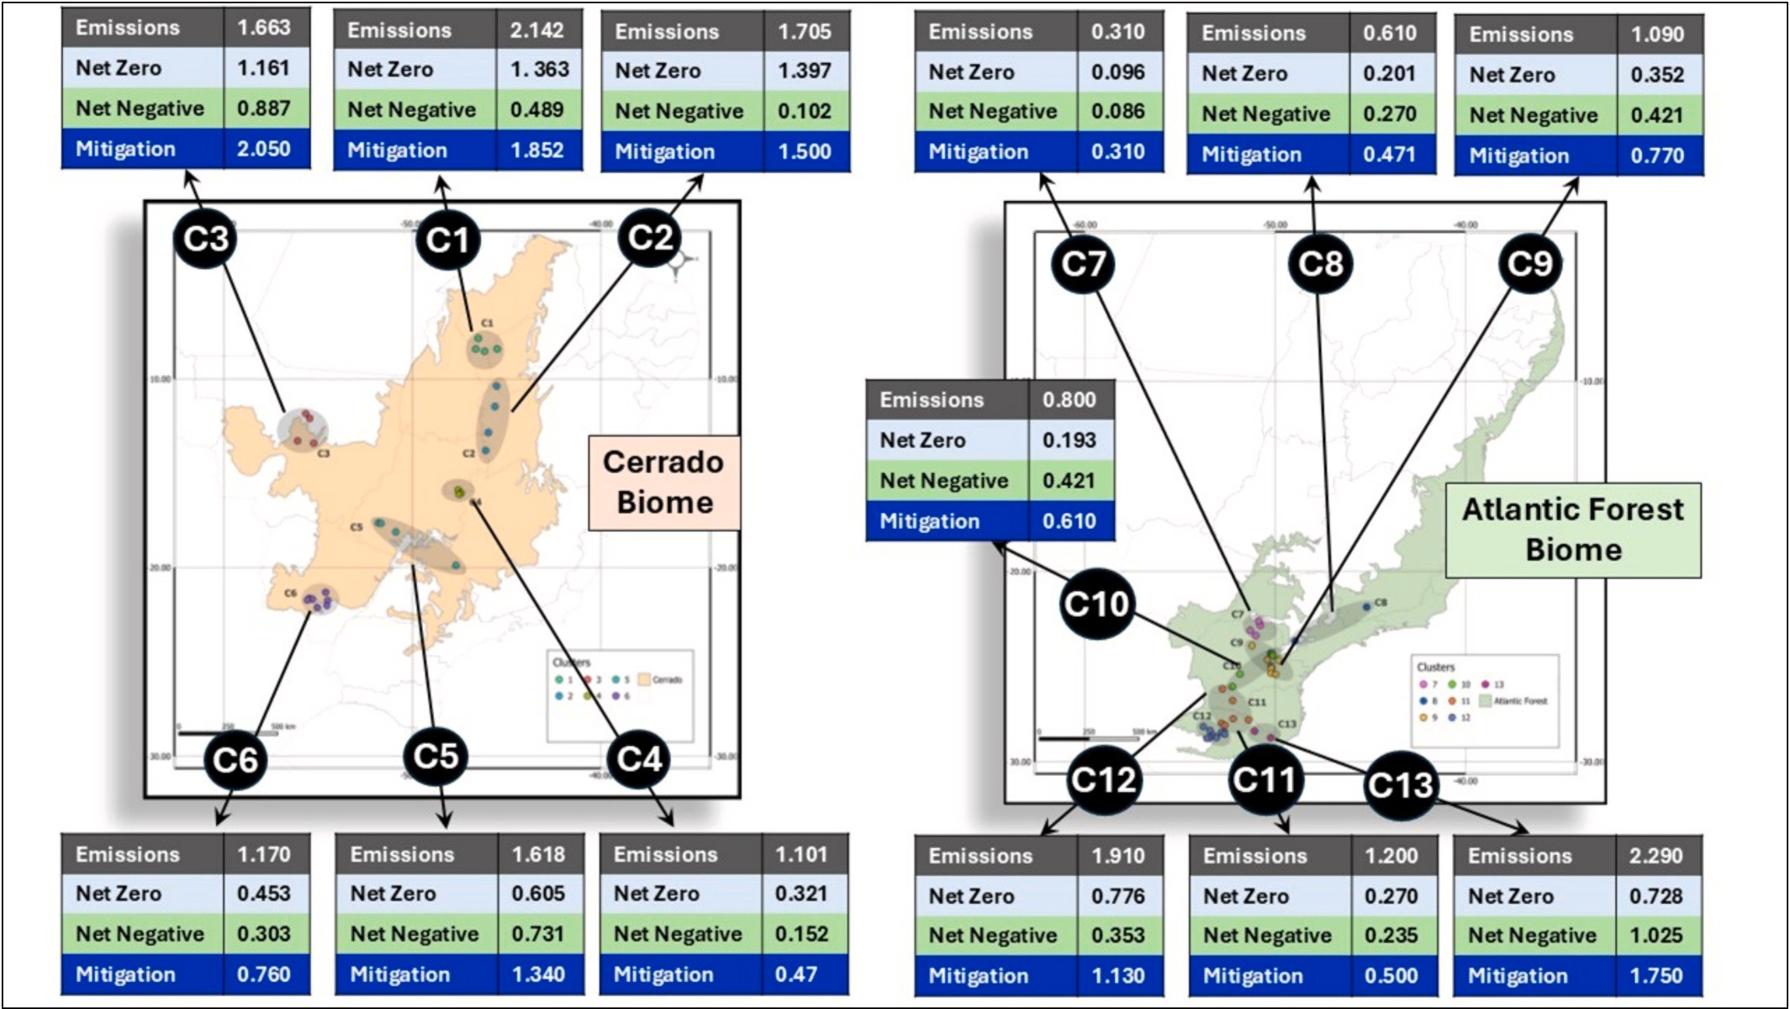

Fig. 7. CO₂e emissions (Tg CO₂e) by plow-based tillage (PBT), net zero and net negative emissions by no-till systems (NTS) and the total mitigation for 13 clusters (C1 to C13).

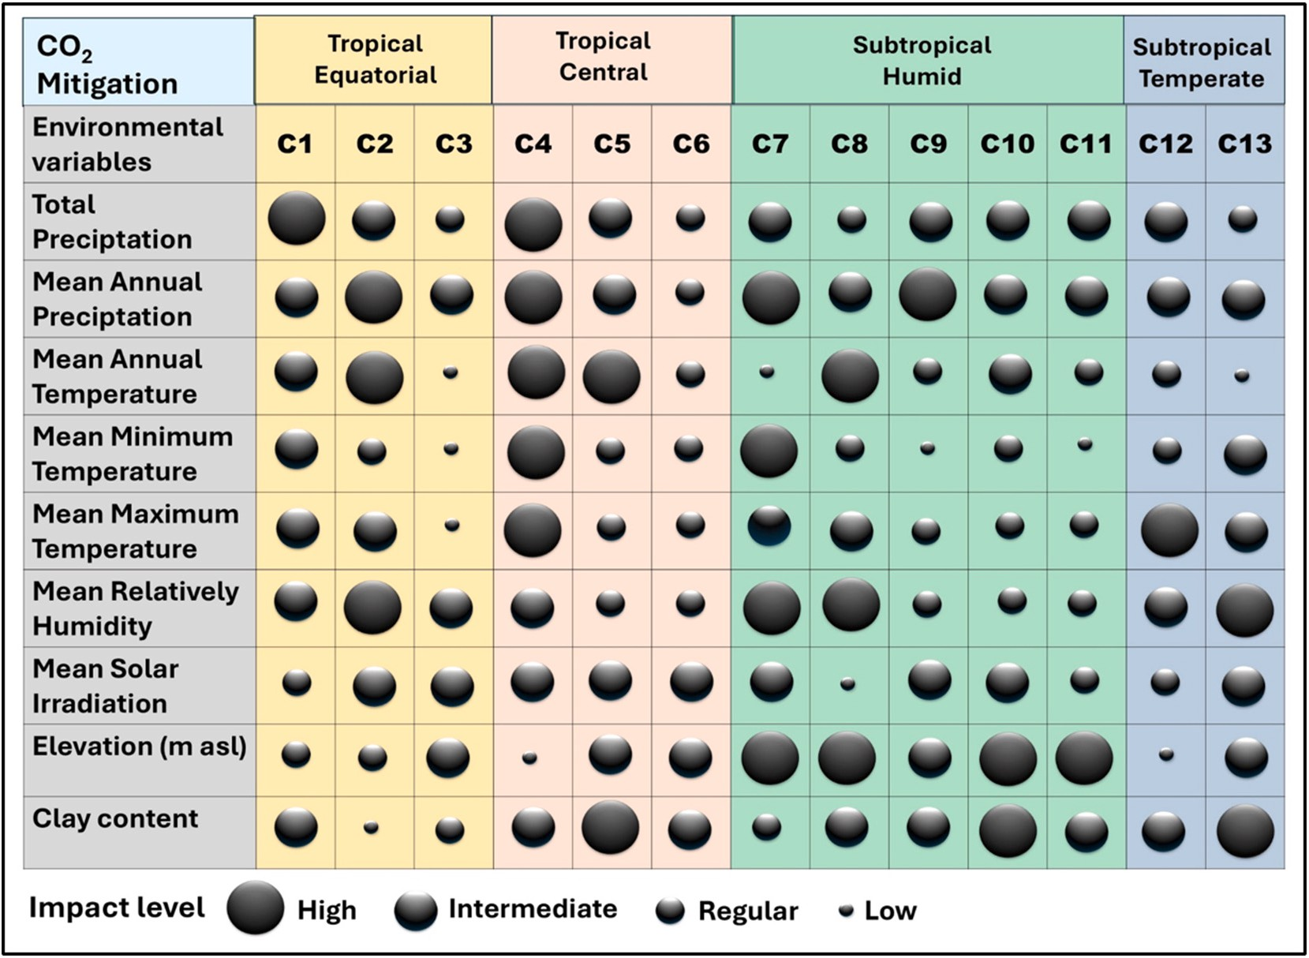

Fig. 8. Rank of environmental co-variables impacts in the CO₂e mitigation by no-till system (NTS) in the 13 clusters (C1 to C13) in four climate zones (tropical equatorial and central, subtropical humid and temperate) in Cerrado and Atlantic Forest biomes.

relative humidity, and mean annual precipitation, which have a positive effect on crop performance. The clay content, in conjunction with the calcium content, facilitates the storage of more carbon due to the bonds formed between organic radicals and calcium, thereby serving as a cationic bridge (Fig. S2).

  - When, how and why net negative emissions can be reached?

The initial step entails the control of soil C oxidation through the adoption of the first and second principles of the NTS (no plowing the soil and the maintenance of permanent soil cover) ensuring the integrity of the aggregates against the impact of raindrops, thereby protecting C within the aggregates (Oades, 1984; Tivet et al., 2013) (Fig. S1). Second step is the amount of biomass-C input above the needs of net zero requirement (Lal, 2021). The relative predominance of each mechanism of C storage is influenced by the annual input of C, the characteristics of the soil matrix, and the prevailing climate patterns (Tivet et al., 2013). Accordingly, the process of soil organic carbon (SOC) sequestration within the natural turnover cycle in NTS (Tivet et al., 2013) is pre- dominantly influenced by aggregation, which functions to reduce rates of decomposition, enhance physical protection of particulate organic carbon (POC), and impede the actions of enzymes and microorganisms (Oades, 1984; Six et al., 1999, 2000). This process occurs through the formation of macroaggregates within the NTS, which serve as the nucleation points for the development of new microaggregates (Briedis et al., 2023; Tisdall and Oades, 1982). The production systems employed in clusters C1, C2, and C3 (Briedis et al., 2023) demonstrate consistency with these assertions due to the utilization of a crop sequence that pri- oritizes an assortment of grasses (i.e., corn [Zea mays] + Congo grass [Brachiaria ruziziencis]), resulting in an input of biomass-C from the previous soybean planting that exceeds 8.5 to 9 Mg C ha^{—1} yr^{—1}, thereby surpassing the net zero requirements (Sa´ et al., 2025).
The hypothesis positing the mechanisms underlying the aggregation of soil particles is predicated upon a hierarchical organization of the
distinct stages of this process, a concept first articulated by Tisdall and Oades (1982) and subsequently elaborated upon by Oades (1984). The processes in question are related to the temporal persistence of the binding agents (e.g., transient, temporary, or persistent) (Six et al., 1999). These processes accentuate the formation of microaggregates (persistent binding agents, primary particles, and iron and aluminum oxides) or stable macroaggregates resulting from the enmeshing effect of fungal hyphae and roots, which are temporary binding agents. The frequency of biomass-C input is based on twice a year corroborate with the C and N fluxes supporting the formation of macroaggregates (Briedis et al., 2012). In summary, soil works as a C sink and the net negative emissions take a place when biomass-C input is greater than output by lost through decomposition processes.
In addition, practices that promote soil improvement, such as liming and gypsum application, contribute to the creation of a favorable environment conducive to net negative emissions. Firstly, an enhance- ment in crop performance can been observed, resulting in an increased return of biomass-C to the soil (S´a et al., 2017). Secondly, calcium (Ca⁺²) has been demonstrated to function as a cation bridge in Oxisols (Briedis et al., 2012; Inagaki et al., 2016), thereby linking the negative charge on the surface of clay particles with the C radicals (i.e., phenol, hydroxyl, and carboxyl) (Inagaki et al., 2016). The quantity of exchangeable Ca⁺² that is capable of binding to a given amount of C is a material parameter of significance to enhance C (Inagaki et al., 2016) (Fig. S2). Further- more, Ca may become an important contributor to increase C seques- tration and an important factor in regulating the C accumulation of agricultural systems, mainly by enhancing soil aggregation (Inagaki et al., 2016) (Fig. S2). With the Ca content increases it enhances SOC sequestration by 0.24 to 0.35 Mg Cha^{—1} yr^{—1} and important enhances soil C stock (Inagaki et al., 2016). As Ca move downwards on the profile can reach up to 60 cm, a marked impact on root development is also observed (Inagaki et al., 2017), resulting in enhanced SOC stock in deeper layers, as evidenced in clusters C1, C2, C3, C8, C10, and C13.
To sum up, the increase in the quantity, quality, and frequency of the

added carbon (C) biomass results in a greater degree of interaction be- tween the chemical, physical, and biological attributes (Sa´ et al., 2022). Consequently, there is an increased capacity to accumulate C in the soil when the NTS are utilized. The mean value obtained for net zero and net negative emissions was 73.63 % and 26.37 %, respectively, across the 13 clusters. The C from net negative emissions signifies the C credit allo- cated to the farmer (Roy et al., 2022). Consequently, in addition to fostering the development of resilient, healthy, and productive soils, these practices contribute to the preservation of the environment for subsequent generations.

Conclusions

Agriculture’s potential role in addressing global warming must take the following points into consideration:

- The magnitude of the CO₂ emissions changed along the climatic gradient from subtropical humid to subtropical temperate, tropical central, and finally tropical equatorial zones.
- The biomass-C input in all clusters surpassed the required levels to attain net zero emissions.
- The production systems employed in the clusters emphasized the cultivation of cover crops during the winter and dry seasons, which substantially increased biomass-C inputs, thereby contributing to significant negative emissions.
- The highest net negative emissions were observed in clayey soils located within the subtropical humid zone, specifically in the clusters C5, C8, C9, C10 and C13.
- The intensification of production systems is achieved through the adoption of NTS, which serves to maximise the addition of biomass-
C. This process enables the attainment of levels that exceed the requisite amount for net zero emissions, thereby facilitating the eventual achievement of net negative emissions.

Supplementary data to this article can be found online at https://doi. org/10.1016/j.scitotenv.2025.180720.

CRediT authorship contribution statement

Joa˜o Carlos de Moraes Sa´: Writing – review & editing, Writing – original draft, Visualization, Validation, Supervision, Resources, Project administration, Methodology, Investigation, Funding acquisition, Formal analysis, Data curation, Conceptualization. Rattan Lal: Writing – review & editing, Writing – original draft, Supervision, Methodology, Data curation, Conceptualization. Klaus Lorenz: Writing – review & editing, Writing – original draft, Visualization, Methodology. Yadunath Bajgai: Writing – review & editing, Writing – original draft, Visualiza- tion, Validation, Methodology. Carla Gavilan: Writing – review & editing, Writing – original draft, Validation, Software, Methodology. Ademir De Oliveira Ferreira: Writing – review & editing, Writing – original draft, Visualization, Validation, Methodology. Clever Briedis: Writing – review & editing, Writing – original draft, Visualization, Validation, Methodology. Thiago Massao Inagaki: Writing – review & editing, Writing – original draft, Visualization, Validation, Methodol- ogy. Daniel Ruiz Potma Gonçalves: Visualization, Validation, Meth- odology. JeanKleber Bortoluzzi: Project administration, Investigation, Funding acquisition, Conceptualization.

Funding

This work was funded by the European Union (EU) through the EUROCLIMA+ program: Global Gateway initiative building partner- ships between the EU and the Latin America and the Caribbean regions under grant # 23-SB1613; and administered by Expertise France: French international technical cooperation agency, with a status of public institution under the joint supervision of the Ministry of Europe and
Foreign Affairs (MEAE) and the Ministries for the Economy, Finance and the Recovery. In addition, the authors J.C.M Sa´ (grant: 311698/2019-0) and De Oliveira Ferreira A. (grant: 317195/2021-2) thank the Conselho Nacional de Desenvolvimento Científico e Tecnolo´gico (CNPq).

Declaration of competing interest

The authors have no competing interests to declare.

Acknowledgments

We are deeply grateful to all 63 farmers who readily opened their doors and joined the No-till System: Basis for Sustainable Agriculture project over the past 4 years. A special thanks to the Brazilian Federation of No-till Systems for all their support during all stages of the project. We are grateful to the precision agriculture companies Rocca, Express˜ao Agricola, Planejar, Dika Consultoria, CGM and Agroconsult who collected the soil samples with great care and competence. We would like to thank the IBRA Megalab laboratory for carrying out the carbon analysis with accuracy and precision. We would like to thank the Min- istry of Agriculture, Livestock and Food Supply for their support during the project submission stages. We would like to thank the anonymous reviewers for their promptness and collaboration in reviewing the text with important suggestions for improving the manuscript. We dedicate this study to the pioneers of No-till in Brazil represented here by Mr. Herbert Bartz (“in memorium”), Manoel Henrique Pereira (“In memo- rium”) and Franke Dijkstra for their immense contribution to the Bra- zilian agriculture.

Data availability

All data are in the main text and supplementary material of this article.

References

Abbass, K., Qasim, M.Z., Song, H., Murshed, M., Mahmood, H., Younis, I., 2022. A review of the global climate change impacts, adaptation, and sustainable mitigation measures. Environ. Sci. Pollut. Res. 29, 42539–42559.
Alvares, C.A., Stape, J.L., Sentelhas, P.C., de Moraes Gonçalves, J.L., 2013. Modeling monthly mean air temperature for Brazil. Theor. Appl. Climatol. 113, 407–427.
Anderson, R., Bayer, P.E., Edwards, D., 2020. Climate change and the need for agricultural adaptation. Curr. Opin. Plant Biol. 56, 197–202.
Bayer, C., Martin-Neto, L., Mielniczuk, J., Pavinato, A., Dieckow, J., 2006. Carbon sequestration in two Brazilian Cerrado soils under no-till. Soil Tillage Res. 86, 237–245.
Boddey, R.M., Jantalia, C.P., ConceiÇA˜O, P.C., Zanatta, J.A., Bayer, C., Mielniczuk, J.,
Dieckow, J., Dos Santos, H.P., Denardin, J.E., Aita, C., Giacomini, S.J., Alves, B.J.R., Urquiaga, S., 2010. Carbon accumulation at depth in Ferralsols under zero-till subtropical agriculture. Glob. Chang. Biol. 16, 784–795.
Brander, M., Francisco, A., Vivian, S., Tett, S., 2021. Carbon accounting for negative emissions technologies, 21, 699–717.
Breiman, L., 2001. Random forests. Mach. Learn. 45, 5–32.
Breiman, L.. Breiman and Cutler’s random forests for classification and regression. R package version 3.3. https://cran.r-project.org/web/packages/randomForest.
Briedis, C., de Moraes Sa´, J.C., Caires, E.F., de Fa´tima Navarro, J., Inagaki, T.M., Boer, A., de Oliveira Ferreira, A., Neto, C.Q., Canalli, L.B., dos Santos, J.B., 2012. Changes in organic matter pools and increases in carbon sequestration in response to surface liming in an Oxisol under long-term no-till. Soil Sci. Soc. Am. J. 76, 151–160.
Briedis, C., de Moraes S´a, J.C., Lal, R., de Oliveira Ferreira, A., Franchini, J.C., Milori, D.
M.B.P., 2023. Preservation of labile organic compounds is the pathway for carbon storage in a 23-year continuous no-till system on a Ferralsol in southern Brazil.
Geoderma Reg. 33, e00643.
Corbeels, M., Scopel, E., Cardoso, A., Bernoux, M., Douzet, J.-M., Neto, M.S., 2006. Soil carbon storage potential of direct seeding mulch-based cropping systems in the Cerrados of Brazil. Glob. Chang. Biol. 12, 1773–1787.
Crippa, M., Solazzo, E., Guizzardi, D., Monforti-Ferrario, F., Tubiello, F.N., Leip, A., 2021. Food systems are responsible for a third of global anthropogenic GHG emissions. Nat. Food. 2, 198–209.
de Oliveira Ferreira, A., Sa´, J.C.M., Harms, M.G., Miara, S., Briedis, C., Quadros Netto, C., Santos, J.B., Canalli, L.B., 2012. Carbon balance and crop residue management in dynamic equilibrium under a no-till system in Campos Gerais. R. Bras. Ci. Solo. 36, 583–1590.
de Oliveira Ferreira, A., Sa´, J.C.M., Lal, R., Jorge Carneiro Amado, T., Massao Inagaki, T.,
Briedis, C., Tivet, F., 2021. Can no-till restore soil organic carbon to levels under

natural vegetation in a subtropical and tropical Typic Quartzipisamment? Land Degrad. Dev. 32, 1742–1750.
Ellert, B.H., Bettany, J.R., 1995. Calculation of organic matter and nutrients stored in soils under contrasting management regimes. Can. J. Soil Sci. 75, 529–538.
Ellert, B.H., Janzen, H.H., McConkey, B.G., 2001. Measuring and comparing soil carbon storage. In: Lal, R., Kimble, J.M., Follett, R.F., Stewart, B.A. (Eds.), Assessment methods for soil carbon, pp. 131–145.
Ellison, S.L.R., Williams, A., 2012. Quantifying uncertainty in analytical measurement, 3rd edition. Teddington, UK, Eurachem/CITAC, 141pp. (CITAC Guide Number 4). Eurachem/CITAC, Teddington, UK.
Fankhauser, S., Smith, S.M., Allen, M., Axelsson, K., Hale, T., Hepburn, C., Kendall, J.M., Khosla, R., Lezaun, J., Mitchell-Larson, E., Obersteiner, M., Rajamani, L.,
Rickaby, R., Seddon, N., Wetzer, T., 2022. The meaning of net zero and how to get it right. Nat. Clim. Chang. 12, 15–21.
FAO, 2021. FAOSTAT Analytical Brief 71: Land Statistics and Indicators 2000–2021 –
Global, Regional and Country Trends. FAO, Rome.
Ferreira, A.C.B., Borin, A.L.D.C., Lamas, F.M., Bogiani, J.C., Silva, M.A.S.d., Silva Filho, J.L.d., Staut, L.A., 2020. Soil carbon accumulation in cotton production systems in the Brazilian Cerrado. Acta Sci. Agron. 42, e43039.
Goulding, K., Jarvis, S., Whitmore, A., 2007. Optimizing nutrient management for farm systems. Philos. Trans. R. Soc. B, Biol. Sci. 363, 667–680. Philos. Trans. R. Soc. Lond. B Biol. Sci.
Griscom, B.W., Adams, J., Ellis, P.W., Houghton, R.A., Lomax, G., Miteva, D.A., Schlesinger, W.H., Shoch, D., Siikam¨aki, J.V., Smith, P., Woodbury, P., Zganjar, C., Blackman, A., Campari, J., Conant, R.T., Delgado, C., Elias, P., Gopalakrishna, T., Hamsik, M.R., Herrero, M., Kiesecker, J., Landis, E., Laestadius, L., Leavitt, S.M., Minnemeyer, S., Polasky, S., Potapov, P., Putz, F.E., Sanderman, J., Silvius, M., Wollenberg, E., Fargione, J., 2017. Natural climate solutions. Proc. Natl. Acad. Sci. 114, 11645–11650.
Hasegawa, T., Fujimori, S., Frank, S., Humpeno¨der, F., Bertram, C., Despr´es, J., Drouet, L., Emmerling, J., Gusti, M., Harmsen, M., Keramidas, K., Ochi, Y.,
Oshiro, K., Rochedo, P., van Ruijven, B., Cabardos, A.-M., Deppermann, A., Fosse, F., Havlik, P., Krey, V., Popp, A., Schaeffer, R., van Vuuren, D., Riahi, K., 2021. Land- based implications of early climate actions without global net-negative emissions. Nat. Sustain. 4, 1052–1059.
Hungria, M., Nogueira, M.A., 2023. Chapter 16- nitrogen fixation. In: Rengel, Z., Cakmak, I., White, P.J. (Eds.), Marschner’s Mineral Nutrition of Plants, Fourth edition. Academic Press, San Diego, pp. 615–650.
Inagaki, T.M., de Moraes Sa´, J.C., Caires, E.F., Gonçalves, D.R.P., 2016. Lime and gypsum application increases biological activity, carbon pools, and agronomic productivity in highly weathered soil. Agric. Ecosyst. Environ. 231, 156–165.
Inagaki, T.M., de Moraes S´a, J.C., Caires, E.F., Gonçalves, D.R.P., 2017. Why does carbon increase in highly weathered soil under no-till upon lime and gypsum use? Sci. Total Environ. 599-600, 523–532.
Jantalia, C.P., Resck, D.V.S., Alves, B.J.R., Zotarelli, L., Urquiaga, S., Boddey, R.M., 2007. Tillage effect on C stocks of a clayey Oxisol under a soybean-based crop rotation in the Brazilian Cerrado region. Soil Tillage Res. 95, 97–109.
Jensen, E.S., Hauggaard-Nielsen, H., 2003. How can increased use of biological N2 fixation in agriculture benefit the environment? Plant Soil 252, 177–186.
Jensen, T.A., Antille, D.L., Tullberg, J.N., 2025. Improving on-farm energy use efficiency by optimizing machinery operations and management: a review. Agric. Res. 14, 15–33.
Jeswani, H.K., Saharudin, D.M., Azapagic, A., 2022. Environmental sustainability of negative emissions technologies: a review. Sustain. Prod. Consum. 33, 608–635.
Kassam, A., Friedrich, T., Derpsch, R., 2022. Successful experiences and lessons from conservation agriculture worldwide. Agronomy 12, 769.
Lal, R., 2021. Negative emission farming. J. Soil Water Conserv. 76, 61A–64A.
Lal, R., Moldenhauer, W.C., 1987. Effects of soil erosion on crop productivity. Crit. Rev.
Plant Sci. 5, 303–367.
Lal, R., Reicosky, D.C., Hanson, J.D., 2007. Evolution of the plow over 10,000 years and the rationale for no-till farming. Soil Tillage Res. 93, 1–12. Soil Tillage Res.
Lovato, T., Mielniczuk, J., Bayer, C., Vezzani, F., 2004. Carbon and nitrogen addition related to stocks of these elements in soil and corn yield under management systems. Rev. Bras. Cieˆnc. Solo 28, 175–187.
Minamisawa, K., 2022. Mitigation of greenhouse gas emission by nitrogen-fixing bacteria. Biosci. Biotechnol. Biochem. 87, 7–12.
Miranda, E., Carmo, J., Couto, E., Camargo, P., 2016. Long-term changes in soil carbon stocks in the Brazilian Cerrado under commercial soybean. Land Degrad. Dev. 27, 1586–1594.
Nyvold, M., Do¨rsch, P., 2025. Nitrous oxide emissions from production, storage and application of nitrogen enriched organic fertilizer. Sci. Total Environ. 977, 179375.
Oades, J.M., 1984. Soil organic matter and structural stability: mechanisms and implications for management. Plant Soil 76, 319–337.
Poore, J., Nemecek, T., 2018. Reducing food’s environmental impacts through producers and consumers. Science 360, 987–992.
Ramesh, T., Bolan, N.S., Kirkham, M.B., Wijesekara, H., Kanchikerimath, M., Srinivasa Rao, C., Sandeep, S., Rinklebe, J., Ok, Y.S., Choudhury, B.U., Wang, H., Tang, C., Wang, X., Song, Z., Freeman Ii, O.W., 2019. Soil organic carbon dynamics: impact of land use changes and management practices: a review. Adv. Agron. 156, 1–107.
Rezende, C.L., Scarano, F.R., Assad, E.D., Joly, C.A., Metzger, J.P., Strassburg, B.B.N., Tabarelli, M., Fonseca, G.A., Mittermeier, R.A., 2018. From hotspot to hopespot: an opportunity for the Brazilian Atlantic Forest. Perspect. Ecol. Conserv. 16, 208–214.
Rouphael, Y., Colla, G., 2020. Editorial: Biostimulants in agriculture. Front. Plant Sci. 11, 40.
Roy, O., Meena, R.S., Kumar, S., Jhariya, M.K., Pradhan, G., 2022. Assessment of land use systems for CO₂ sequestration, carbon credit potential, and income security in Vindhyan region, India. Land Degrad. Dev. 33, 670–682.
S´a, J.C.M., Cerri, C.C., Dick, W.A., Lal, R., Filho, S.P.V., Piccolo, M.C., Feigl, B.E., 2001.
Organic matter dynamics and carbon sequestration rates for a tillage chronosequence in a Brazilian Oxisol. Soil Sci. Soc. Am. J. 65, 1486–1499.
S´a, J.C.M., Se´guy, L., Tivet, F., Lal, R., Bouzinac, S., Borszowskei, P.R., Briedis, C., dos
Santos, J.B., da Cruz Hartman, D., Bertoloni, C.G., Rosa, J., Friedrich, T., 2015. Carbon depletion by plowing and its restoration by no-till cropping systems in Oxisols of subtropical and tropical agro-ecoregions in Brazil. Land Degrad. Dev. 26, 531–543.
S´a, J.C.M., Lal, R., Cerri, C.C., Lorenz, K., Hungria, M., de Faccio Carvalho, P.C., 2017.
Low-carbon agriculture in South America to mitigate global climate change and advance food security. Environ. Int. 98, 102–112.
S´a, J.C.M., Lal, R., Briedis, C., de Oliveira Ferreira, A., Tivet, F., Inagaki, T.M., Potma Gonçalves, D.R., Canalli, L.B., Burkner dos Santos, J., Romaniw, J., 2022. Can C- budget of natural capital be restored through conservation agriculture in a tropical and subtropical environment? Environ. Pollut. 298, 118817.
S´a, J.C.M., Lal, R., Lorenz, K., Bajgai, Y., Gavilan, C., Kapoor, M., Ferreira, A.D.O.,
Briedis, C., Inagaki, T.M., Canalli, L.B., Gonçalves, D.R.P., Bortoluzzi, J., 2025. No- till systems restore soil organic carbon stock in Brazilian biomes and contribute to the climate solution. Sci. Total Environ. 977, 179370.
Six, J., Elliott, E.T., Paustian, K., 1999. Aggregate and soil organic matter dynamics under conventional and no-tillage systems. Soil Sci. Soc. Am. J. 63, 1350–1358.
Six, J., Elliott, E.T., Paustian, K., 2000. Soil macroaggregate turnover and microaggregate formation: a mechanism for C sequestration under no-tillage agriculture. Soil Biol. Biochem. 32, 2099–2103.
Tisdall, J.M., Oades, J.M., 1982. Organic matter and water-stable aggregates in soils.
J. Soil Sci. 33, 141–163.
Tivet, F., de Moraes S´a, J.C., Lal, R., Briedis, C., Borszowskei, P.R., dos Santos, J.B., Farias, A., Eurich, G., Hartman, D.d.C., Nadolny Junior, M., Bouzinac, S., S´eguy, L., 2013. Aggregate c depletion by plowing and its restoration by diverse biomass-c inputs under no-till in sub-tropical and tropical regions of Brazil. Soil Tillage Res. 126, 203–218. Soil Tillage Res.
von Luxburg, U., 2007. A tutorial on spectral clustering. Stat. Comput. 17, 395–416.
Wang, C., Amon, B., Schulz, K., Mehdi, B., 2021. Factors that influence nitrous oxide emissions from agricultural soils as well as their representation in simulation models: a review. Agronomy 11.
Yang, P., Li, J., Hou, R., Yuan, R., Chen, Y., Liu, W., Yu, G., Wang, W., Zhou, B., Chen, Z., Chen, H., 2024. Mitigating N2O emissions in land treatment systems: mechanisms, influences, and future directions. Sci. Total Environ. 951, 175638.
Zulfiqar, F., Moosa, A., Ali, H.M., Bermejo, N.F., Munne´-Bosch, S., 2024. Biostimulants: a sufficiently effective tool for sustainable agriculture in the era of climate change? Plant Physiol. Biochem. 211, 108699.

